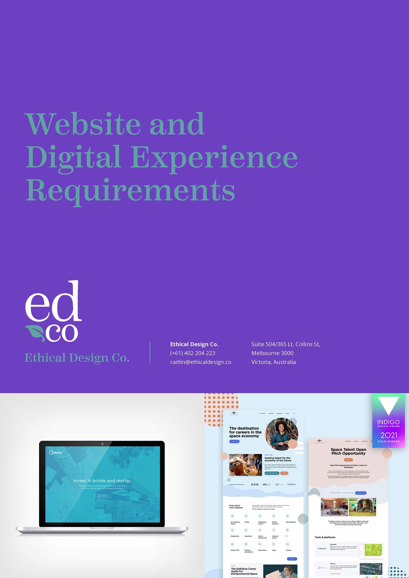
Ethical Design Co.: Fillable Client Form

Introduction
The purpose of this document is to the capture design, technical and functionality requirements of your digital project. It’s important to understand each of these areas in as much detail as possible in order to correctly estimate the effort and cost of such a project.
We understand that some of these things may not yet be fully understood. The primary goal here is to ensure we understand the scope of the project, as it currently stands, and then propose the most valuable solutions for your needs.
Once you have had a chance to fill in the questions, the next step will be for us to estimate how much effort will be required for each phase of the project (discovery, design, development), and what will be expected by whom. Note that these phases will be explained in more detail in your proposal.

Process
Once we receive this document from you, the process will be as follows:
- We provide some pricing, timelines and a general proposal of how we might move forward – this will include costs for other deliverables including brand design and design for package labelling as discussed separately (see: our EDCo. logo and brand briefing form if you require a logo or branding package).
- If you’re happy, you can accept our proposal + Terms & Conditions and we will schedule in the work and begin to manage and organise whoever is responsible for each component of the project.
- We will use this document as our design brief and refer to it as needed throughout the process.

PLEASE FILL IN THE BELOW

Background Information
- New or replacement site?
- If replacement, what is the current domain (URL) and:
  - Analytics used / account access or reports?
  - Motivation for change?
- What are the organisational goals for the website?
  - What do you want to achieve from the new site? (Goals should be SMART: specific, measurable, achievable, realistic, and have a timeframe)
- Please describe the organisation’s background, its vision, mission and main message to its target audience - what does the organisation do? Provide a short summary with products/services/history etc.

About the Business/Organisation
- Who is your target audience?
  - May be more than one group / may be different from your customers or clients.

*For example, a non-profit tackling youth issues may have a target market of 18 - 25yo but its target audience may be individual donations and corporate sponsors.
  - Do you have an ideal customer profile?
  - What will they come to your website for? (articles/reviews/contact details/pricing?)

Content
- Do you have an idea of how many/which pages your website will need?
*For example: ‘Home’, ‘About’, ‘Services’ etc.
- Who is going to write the content, or edit the old content for the new site? Will it be done with Search Engine Optimisation in mind? (See SEO section below.)
  - Do you want us to put you in touch with a copywriter/editor to help with the content writing or will you do this yourself and/or from within the organisation?

Call to Action
- What do you want people to do when they get to the site?
Please describe the major objectives for the site, as well as the activities you would like users to perform.

*For example, we would like the general user to engage in the following activities on our website:
- Donate online
- Subscribe to our newsletter
- Subscribe to our blog RSS feed
- Follow us on social media channels Twitter and Facebook
- Purchase our merchandise
- Contribute blog comments
- Contact us
- Download resources on “going green”

- What are the major website objectives?
Please describe the major objectives for the site.

*For example:
- Create awareness about our organisation
- Generate donations and merchandise sales
- Build an online community
- Build a repository for resources and materials on “going green”
- Advertise uniqueness of organisation to partners, volunteers and the media

Functional Requirements
- What are the functionality requirements of your website? Please describe any unique processes or functions the website will need.

*For example:
- Members only content area (paid or free)
- E-commerce capabilities (including a sub-set of specific features, such as having specials, discounts, featured products, customer reviews, etc).
- Advertising or sponsors
- Language translator
- A blog
- Social media widgets for activity stream

Social Media and Sharing
- Where do you target audience(s) spend time online?
- What avenues do you need for sharing your content? (e.g. links on the page using Social Sharing to LinkedIn, Facebook, Twitter, Instagram, etc.)
- What Social Media presence do you currently have (or need)? – and how is that going to be presented on the site (e.g. Facebook Like box, follow us on Twitter, include the latest from your Twitter stream, etc.).

Design Assets
- If applicable – please provide us with your current logo, brand style guide (including colours, fonts, icon library), brand imagery or illustrations and off-line marketing materials (e.g. brochures, flyers, other promotional collateral).
- If you require logo design or branding for your new business – please refer to our EDCo. logo and brand briefing form.

Design Ideas / Inspiration
- If a rebuild of the current site – what do you like/dislike about the current site?
- What are 3-5 websites with design ideas that you like (can be from your industry or another)
1.
2.
3.
4.
5.

- What are your competitor’s websites (please list 3-5)
1.
2.
3.
4.
5.

Practical Issues
- What’s your budget?
  - Is it realistic for the features and functions you want?
  - What are the priority issues, and can it be staged if the budget doesn’t cover the wish-list?
- What is your ideal timeline?
  - Is the deadline fixed or flexible?

Technology issues
- Is there anything we should know about?

Search Engine Optimisation (SEO)
- Do you have a set of priority keywords and phrases?
- Will this be addressed in the build / how? Whether we manage your SEO or otherwise, we will need to know your content and SEO strategy before we build the site.
- How is this measured after the build? what are the metrics / KPI’s (before and after analysis of traffic, referring sites, terms?)

